## **How To Use Volume-Weighted RSI (VWRSI)**

##### **What VWRSI Tells You**

The **VWRSI** measures momentum just like the standard RSI, but it weighs each move by **trading volume**.

* A price move on **high volume** has more influence than a move on **low volume**.
* ***This filters out “false RSI signals” that occur in thinly traded periods.***
  + End result? A momentum oscillator that better reflects **true market participation**.

##### **Use Cases**

**Trend Identification**

* Above 50 → bullish momentum (weighted by strong volume).
* Below 50 → bearish momentum.
* This makes 50 a **trend filter line**: only take long setups when RSI > 50 with high volume, shorts when RSI < 50.

*Yellow RSI 50 Median Line*

**Overbought & Oversold Conditions**

* 70–100 zone → overbought.
  + But unlike normal RSI, VWRSI here means buyers were active on high volume → stronger exhaustion signal.
* 30–0 zone → oversold.
  + Selling pressure occurred on volume → stronger rebound potential.

**Divergences**

* Price makes new highs, but VWRSI fails to confirm → **bearish divergence**.
* Prices make new lows, but VWRSI fails to confirm → **bullish divergence**.
* ***Divergences are more reliable with VWRSI since they incorporate volume.***

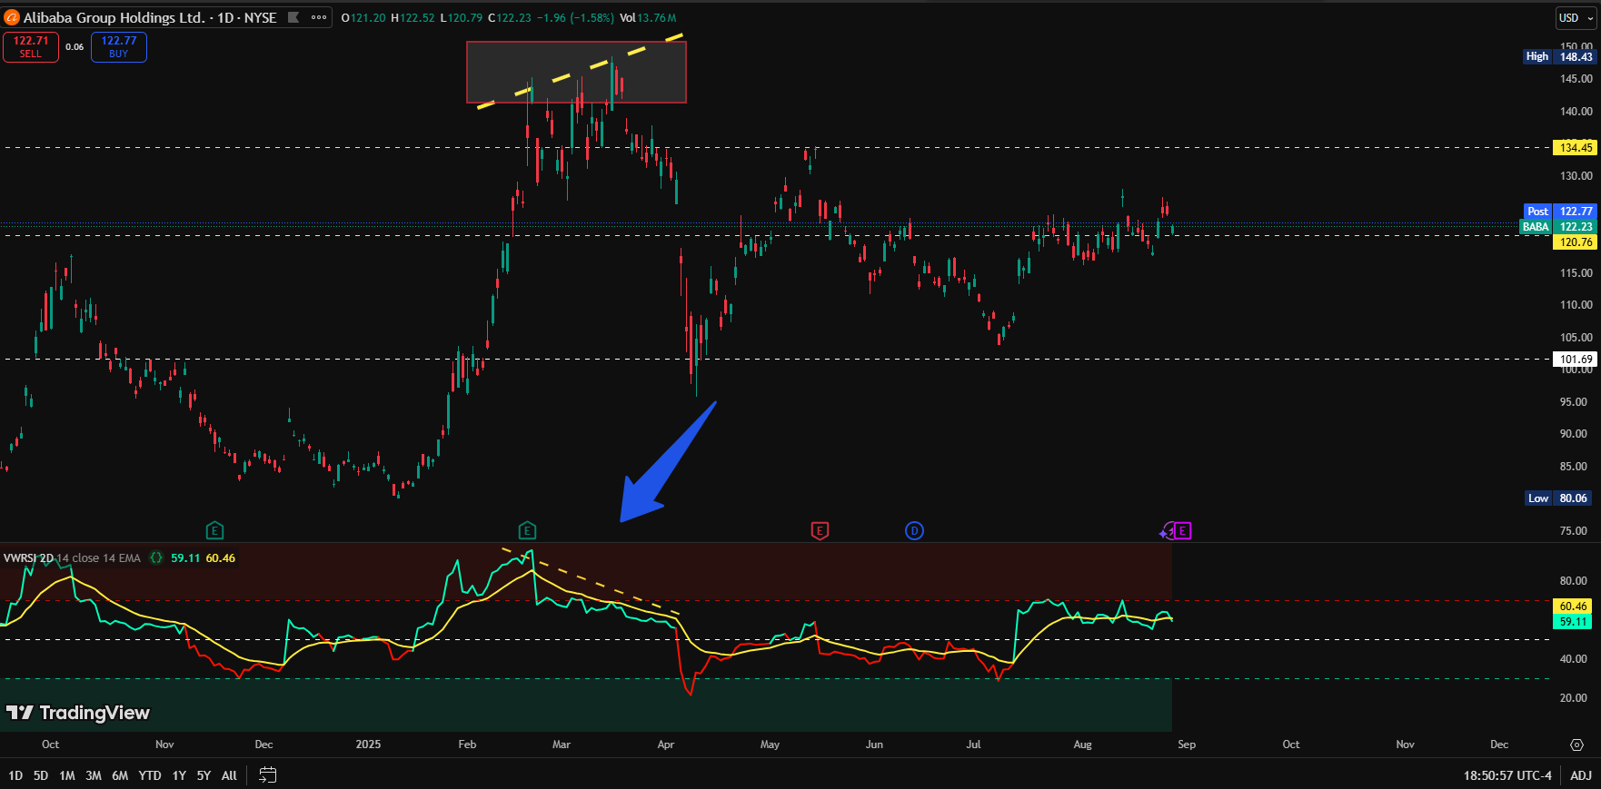

Look at this example with Alibaba Stock: we get two signals with our Volume-Weighted RSI indicator. First, price is overbought—RSI is over 70, and volume confirms the move — but daily candle closing is red. **That suggests distribution.** Furthermore, as time progresses, $BABA sets new highs, but the VWRSI fails to follow. **That’s a clear bearish divergence.**

Reversal & Entry Signals

* Buy signal → VWRSI crossing up through 30.
* Sell signal → VWRSI crossing down through 70.
* Trend confirmation → VWRSI crossing above/below 50.

##### **Configurations & Best Practices**

**RSI Length**

* Default = 14 works across most charts.
* Intraday (1m–30m) → use 21–28 to reduce noise.
* 1h–4h → stick with 14–21.
* Daily → keep 14.
* Weekly / Monthly → shorten to 9–10 to avoid over-smoothing.
* Set RSI Length and RSI MA to be the same when on different timeframes.
  + This keeps the oscillator’s smoothing consistent.

Rule of thumb: *longer length for lower timeframes (filters noise), shorter length for higher timeframes (captures turns earlier).*

Moving Average (RSI MA)

* Smoothing RSI with a moving average (EMA/SMA/RMA/WMA) reduces whipsaws.
* **EMA** → fast & reactive, best for scalping/intraday.
* **SMA** → more balanced, best for swing trading.
* **RMA/WMA** → smoother for higher timeframes.
* Use crossovers of RSI vs RSI MA as entry/exit signals.

**Colors & Visual Setup**

* Bullish color above 50 → quick trend spotting.
* Bearish color below 50 → easy visual filtering.
* Customize MA color separately for clarity.
* Keep overbought/oversold bands shaded (70/30) for easy recognition.

##### **Using RSI MA with VWRSI — Crossovers & Best Practices**

What is RSI MA?

* The RSI MA (Moving Average of RSI) is simply a moving average applied to the RSI line.
  + RSI MA smooths out short-term fluctuations.
  + Filters noise (especially on lower timeframes).
  + Provides a reference line for crossovers → clearer entry/exit signals.

##### **Crossover Strategy**

**Bullish Entry Signal**

* Condition: RSI crosses above its MA.
* Meaning: short-term momentum is accelerating faster than the average momentum.
  + Buyers are stepping in with volume.
* Best used when RSI is above 50 (trend confirmation).

**Bearish Entry/Exit Signal**

* **Condition**: RSI crosses **below** its MA.
* Meaning: short-term momentum is weakening relative to average.
  + Sellers gaining strength.
* Best used when RSI is **below 50**.